Lab 05

Querying data and Joins / Relates

Querying data from larger datasets are often essential to display only desired data and attributes. In this lab you will use the joins and relates geoprocessing tools to learn how to access additional attribute information that does not exist in the original geographic data set. The goal of this lab is to provide you with the skills necessary to query and access data. General instructions are provided as a guide. General instructions are provided. In order to complete the lab online help resources should be used (ArcGIS help). Deliverables are what will need to be turned in for credit, and are outlined following the instructions.

Key Search Terms: Joins, Relates, Connections, Definition Query, Select by Attribute, Clause

Instructions:
- Create a new map in ArcGIS Pro.
- Add the weather station point data and county polygon from the Lab 05 geodatabase.
- Create a definition query to show weather stations in Utah that are Active (right click on the layer and select “Properties” to create a definition query).
- Use “Select by Attribute” to select all records in the SNOTEL network. Export the selected features as a new feature titled “Active_SNOTEL_Stations.”
- In the County feature, use a definition query to select only Cache, Weber, and Rich counties.
- Use a Select by Location to select only the stations that are active within Cache, Weber, and Rich counties. Export this as a new feature titled “SNOTEL_Sites_Study_Area.”
- Generate a report for the precipitation accumulation totals for the 2016 year to join to these points.
  - https://wcc.sc.egov.usda.gov/reportGenerator/
    - Open the link using Google Chrome.
  - Utilizing the above report generator by inputting the 10 stations, selecting precipitation accumulation in “Data,” and then selecting the correct Interval/Duration in the “Time Period” section. Use these inputs for the report:
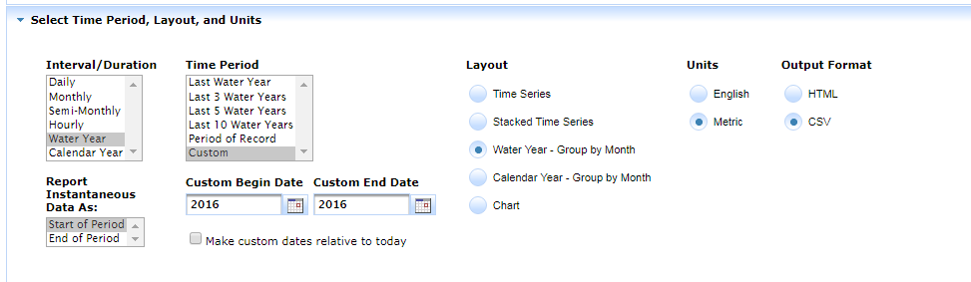
  - To save the reports, click the View report button, then right click the page and click Save As. Save the reports as filename.csv, with a relevant file name for each report. (Hint: It may be helpful to save this file as “annual” and the file in the next step as “monthly”)
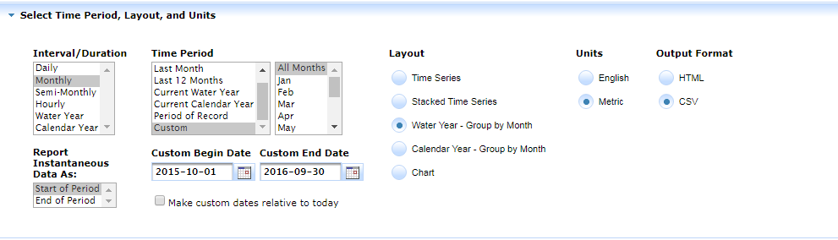
  - Additionally, download a monthly breakdown for 2016 showing precipitation accumulation by month. Use these inputs to create the monthly report:

  - Open the reports using Excel, and clean up the data for use in ArcGIS. This consists of deleting any rows not containing either the header or the attribute values desired (typically have a # in front of them).
  - Import these CSVs into ArcGIS using the Add Data button in the Map tab. Export each CSV as geodatabase tables (hint: you may want to add these to your Lab 5 geodatabase).
- Join the 2016 annual report to the SNOTEL feature class based on “Station Name” and create a map using proportional symbols based on 2016 total accumulation for each station. Be sure to label the Counties, and the Station Name and Precipitation accumulation for each station.
  - To create a label with multiple attributes, click the Label Expression Dialog box under the Labeling tab.
  - Search “line break” for help writing the expression for the label. An example is included here.
    - “Counties:” + $feature + “Station name:” + $feature + “Precipitation:” + $feature
- Remove the join and relate the monthly data to each record. Review that each point has 12 months’ worth of precipitation data related and Save the Project. Take a screenshot of the related data for Ben Lomond Peak.
Deliverables:
- A layout map displaying the location of SNOTEL locations within Utah utilizing a NAD 83 Zone 12 projection symbolized using proportional symbols based on 2016 annual precipitation accumulation.
- A short, half-page, write up concerning when you would want to use a join vs. when you would want to use a relate.
- A screenshot of the related data for the Ben Lomond Peak SNOTEL site within ArcGIS Pro.

